1.Program to print your name, date of birth, mobile number, and college name:

#include<stdio.h>
int main() {
char name[] = "Arman Rai";
char dob[] = "2005-05-05";
char mobileNo[] = "+977 9876543210";
char campus[] = "Patan Multiple Campus";

printf("Name: ");
puts(name);
printf("DOB: ");
puts(dob);
printf("Mobile number: ");
puts(mobileNo);
printf("Campus: ");
puts(campus);

return 0;
}

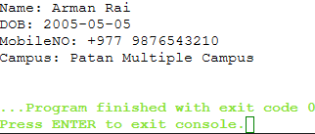

2.Program to display size in bytes of different data types:

#include<stdio.h>
int main() {
printf("Size of int: %lu bytes\n", sizeof(int));
printf("Size of float: %lu bytes\n", sizeof(float));
printf("Size of double: %lu bytes\n", sizeof(double));
printf("Size of char: %lu byte\n", sizeof(char));

return 0;
}

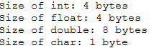

3.Program to compute the area and circumference of a circle:

#include<stdio.h>
#define PI 3.14159
int main() {
float radius, area, circumference;

printf("Enter the radius of the circle: ");
scanf("%f", &radius);

area = PI * radius * radius;
circumference = 2 * PI * radius;

printf("Area of the circle = %.2f sq meters\n", area);
printf("Circumference of the circle = %.2f meters\n", circumference);

return 0;
}

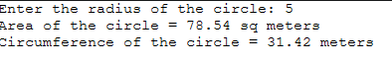

4.Program to convert specified number of days into years, weeks, and days:

#include<stdio.h>
int main() {
int days, years, weeks;

printf("Enter the number of days: ");
scanf("%d", &days);

years = days / 365;
weeks = (days % 365) / 7;
days = days - (years * 365 + weeks * 7);

printf("Years: %d\n", years);
printf("Weeks: %d\n", weeks);
printf("Days: %d\n", days);

return 0;
}

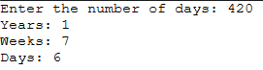

5. Program that accepts two integers from the user and calculates the sum, difference, product, quotient, and remainder:

#include<stdio.h>
int main() {
int num1, num2, sum, diff, product, quotient, remainder;

printf("Enter two integers: ");
scanf("%d %d", &num1, &num2);

sum = num1 + num2;
diff = num1 - num2;
product = num1 * num2;
quotient = num1 / num2;
remainder = num1 % num2;

printf("Sum: %d\n", sum);
printf("Difference: %d\n", diff);
printf("Product: %d\n", product);
printf("Quotient: %d\n", quotient);
printf("Remainder: %d\n", remainder);

return 0;
}

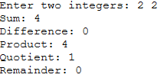

6.Quadratic Equation Roots

#include <stdio.h>
#include <math.h>

int main() {
double a, b, c, discriminant, root1, root2, realPart, imaginaryPart;

printf("Enter coefficients a, b and c: ");
scanf("%lf %lf %lf",&a, &b, &c);

discriminant = b*b-4*a*c;

if (discriminant > 0) {
root1 = (-b+sqrt(discriminant))/(2*a);
root2 = (-b-sqrt(discriminant))/(2*a);
printf("Roots are real and different.\n");
printf("root1 = %.2lf and root2 = %.2lf",root1 , root2);
}
else if (discriminant == 0) {
root1 = root2 = -b/(2*a);
printf("Roots are real and same.\n");
printf("root1 = %.2lf and root2 = %.2lf",root1 , root2);
}
else {
realPart = -b/(2*a);
imaginaryPart = sqrt(-discriminant)/(2*a);
printf("Roots are complex and different.\n");
printf("root1 = %.2lf+%.2lfi and root2 = %.2f-%.2fi", realPart, imaginaryPart, realPart, imaginaryPart);
}

return 0;
}

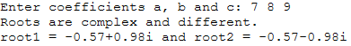

7. Check Integer Type

#include <stdio.h>

int main() {
int num;
printf("Enter an integer: ");
scanf("%d", &num);

if(num >= 0) {
if(num % 2 == 0)
printf("%d is positive even.", num);
else
printf("%d is positive odd.", num);
}
else {
if(num % 2 == 0)
printf("%d is negative even.", num);
else
printf("%d is negative odd.", num);
}

return 0;
}

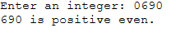

8. Student Grade

#include <stdio.h>

int main() {
int score;
printf("Enter the score: ");
scanf("%d", &score);

if(score >= 80) {
printf("Distinction");
}
else if(score >= 70) {
printf("First Division");
}
else if(score >= 55) {
printf("Second Division");
}
else if(score >= 40) {
printf("Third Division");
}
else {
printf("Fail");
}

return 0;
}

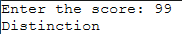

9. Sum of First 100 Natural Numbers

#include <stdio.h>

int main() {
int sum = 0;

for(int i = 1; i <= 100; i++) {
sum += i;
}

printf("The sum of the first 100 natural numbers is %d", sum);

return 0;
}

10. Multiplication Table

#include <stdio.h>

int main() {
int n;
printf("Enter a number: ");
scanf("%d", &n);

for(int i = 1; i <= 10; i++) {
printf("%d * %d = %d\n", n, i, n*i);
}

return 0;
}

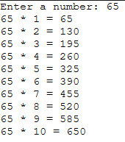

11. Factorial of a number

// using `for loop`
#include <stdio.h>

int main() {
int n, i;
unsigned long long factorial = 1;

printf("Enter an integer: ");
scanf("%d",&n);

if (n < 0)
printf("error: factorial is non-existent.");
else {
for(i = 1; i <= n; ++i) {
factorial *= i;
}
printf("Factorial of %d = %llu", n, factorial);
}

return 0;
}

// using `while loop`
#include <stdio.h>

int main() {
int n, i = 1;
unsigned long long factorial = 1;

printf("Enter an integer: ");
scanf("%d",&n);

if (n < 0)
printf("error: factorial nai hudaina.");
else {
while(i <= n) {
factorial *= i;
++i;
}
printf("Factorial of %d = %llu", n, factorial);
}

return 0;
}

// using `do-while loop`
#include <stdio.h>

int main() {
int n, i = 1;
unsigned long long factorial = 1;

printf("Enter an integer: ");
scanf("%d",&n);

if (n < 0)
printf("Error! Factorial of a negative number doesn't exist.");
else {
do {
factorial *= i;
++i;
} while(i <= n);
printf("Factorial of %d = %llu", n, factorial);
}

return 0;
}

